CO RPO RATE VALUATION

CASE STUDY

**REPORTED BY**

Carl Nchanda

Yahoo! Finance: [GS 309.51 -6.75 -2.13: The Goldman Sachs Group, Inc. - Yahoo Finance](https://finance.yahoo.com/quote/GS/key-statistics?p=GS)

**CONTENT**

1. *Evaluate the firm using the discounted cash flow approach*
2. *Estimates the firm’s WACC*
3. *Conduct scenario analysis and breakeven analysis*
4. *Evaluate the firm using comparable*
5. *Additional analysis*
6. *References*

**ANALYSIS**

## Evaluate the firm using the discounted cash flow approach

* **Financial statements:** Regarding the forecasting of the financial statements of Goldman Sachs, we have used the last five years (2018 to 2021) to calculate the average growth rate of each component of the income statement, balance sheet and cash flow statement. Then we have assumed that for the upcoming years (2022 to 2032), each component will increase by the average growth rate. For example, to determine the value of the revenue for 2022, we use the revenue of 2021*(1+average growth rate of the revenue over the last four years) (19%). We have used the average growth rate because it permits us to take in account all the data of the company over the years and to have a global idea on the growth of the company. The same logic applies to othervariables as well.
* To **calculate the free cash flow**, we have assumed that the tax rate will remain the same over the upcoming years (20%), so we have calculated the tax rate of 2021and use it to determine the free cash flow of 2022,2023,2024,2025,2026,2027,2028,2029,2030,2031 and 2032, also regarding the variation of NWC for 2021, we have used the NWC of 2020.
* (cf: Excel Sheet, for calculation of Free Cash Flow) **(in million $)**

# ASSUMPTIONS

|  |  |
| --- | --- |
| **Variables** | **Average Growth**  **Rate** |
| Income from continuing operations before income taxes | 11.6% |
| Total current assets | 28.02% |
| Total current liabilities | 12.28% |
| CAPEX | 15.17% |
| Depreciation | 12.5% |
| Taxe rate | 20% |

|  |  |  |  |  |  |
| --- | --- | --- | --- | --- | --- |
|  | **2018** | **2019** | **2020** | **2021** | **2022** |
| EBIT | 16,944 | 18,478 | 28,947 | 39,052 | 49,557.867 |
| Depreciation and Amortization | 1,328 | 1,704 | 1,902 | 2,015 | 2,266.937 |
| NWC |  |  |  |  |  |
|  | (101,762) | (104,996) | (72,869) | (92,245) | (76,815) |
| Variation of NWC |  |  |  |  |  |
|  |  |  | 32,127 |  |  |
|  | (101,762) | (3,234) |  | (19,376) | 15,429 |
| CAPEX |  |  |  |  |  |
|  |  |  | (6,309) |  |  |
|  | (7,982) | (8,443) |  | (4,667) | (3,958) |
| **Free cash flow** |  |  |  |  |  |
|  | **109,307** | **11,276** | **-14,592** | **47,965** | **33,538** |

1. Formula used: EBIT(1-T) +DA-delta NWC-CAPEX
2. all numbers recorded in millions
3. tax rate at 20%

## Estimates the firm’s WACC

* 1. CAPM: for the estimation of equity cost of capital

To be able to estimate the equity cost of capital, we begin by estimating the capital structure of the company. In our case, Goldman Sachs’s capital structure is as followed:

- Wd = 84.09%

- We = 15.91%

We then calculate the cost of equity and the cost of debt. The risk-free rate used here was found on Yahoo! Finance, the market risk premium was found on Analyzing Alpha, and the Beta was calculated using historical data found on Yahoo! Finance. At last, the cost of debtwas found thanks to the yield to maturity of bonds issued by the company, this info was found on finra- markets.morningstar.com

- Market risk premium = 4.20%

- Beta = 1,467719

- Ke = 8.12%

- Kd = 88.385%

- Taxe rate= 20%

With this different information found, we can estimate Goldman Sachs Weighted Average Cost of Capital (WACC).

- WACC = 75.615%

## Conduct scenario analysis and breakeven analysis

### Calculate NPV

After estimating the WACC which is 75.615%. We will now calculate the NPV to determine how confident we can be that the project is going as planned. Whether we should accept this one or reject it for investment.

After calculating the NPV with excel formula then using free cash flow and WACC, we get: NPV = 312 200 349 $. we’re calculating the Net present Value from the Net Future Cash Flows from a company’s revenue, and unlike an investment project, we won’t have initial monetary investment.

### Scenario Analysis

In the past analysis, we assumed that all variables continue to grow at the rate of past-5-year average, and the tax rate would remain constant. However, as the newly sworn in U.S. President Biden want for during his first meeting to increase the corporate tax rate to 25% in his effort of “caring” about the economy. Though its implications may be ambiguous now, we assume that there’s two immediate effects on the changes that may affect Goldman Sachs features in two variables:

1. The tax rate used in calculation will rise to 25 % instead of 20%
2. The EBIT will not grow but the change will not be too strong. all other variables remain the same (in thousands $)

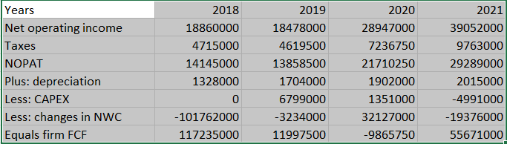

* 1. Formula used: EBIT(1-T) +DA-delta NWC-CAPEX
  2. all numbers recorded in millions

. iii. tax rate at 20%

Then, the WACC would change to 75.615 **%**

#### Breakeven Analysis.

By using the Goal Seek function in excel, we can easily find the growth rate needed for the company to have a NPV of 0. When we did the computation, we found that, for it to happen, the company’s sale in 2018 should be 31340766.11. The growth rate is still positive and higher than the following year.

## Evaluate the firm using comparable

* 1. How do you choose comparable companies?
  2. Which valuation ratio provides more reliable estimates? Why?

##### EV= MC+D-C, where EV (in million $ ) is Enterprise Valuation, D is total interest- bearing debt (high due to the investment bank industry),and C stands for Cash and its equivalents.

|  |  |  |  |  |
| --- | --- | --- | --- | --- |
|  | **12/30/2021** | **12/30/2020** | **12/30/2019** | **12/30/2018** |
| Shares issued(outstanding) | 390 | 376 | 360 | 356 |
| Multiplier: Share Price | 159,3282051 | 216,5292553 | 252,0389 | 359,761236 |
| Market Capitalization | 62138 | 81415 | 90734 | 128075 |
| Plus: Total Debt | 841,611 | 902,703 | 1067,09 | 1336,933 |
| Less: Cash, Cash equivalent & Federal Funds Sold | 405,09 | 355,308 | 406,062 | 611,563 |
| **= Enterprise Valuation** | 61701,479 | 80867,605 | 90072,97 | 127349,63 |

1. ***Historical Data of Goldman Sachs’s EV***

As stock prices continue to present a volatile nature, the EV calculation might be correlated influenced by it as one of the most deciding variants in the calculation process.

Nevertheless, the trend could be observed as the macroeconomic environment recovering from the pandemic-prone countries and regions, its valuation steadily augmented from early 2018.

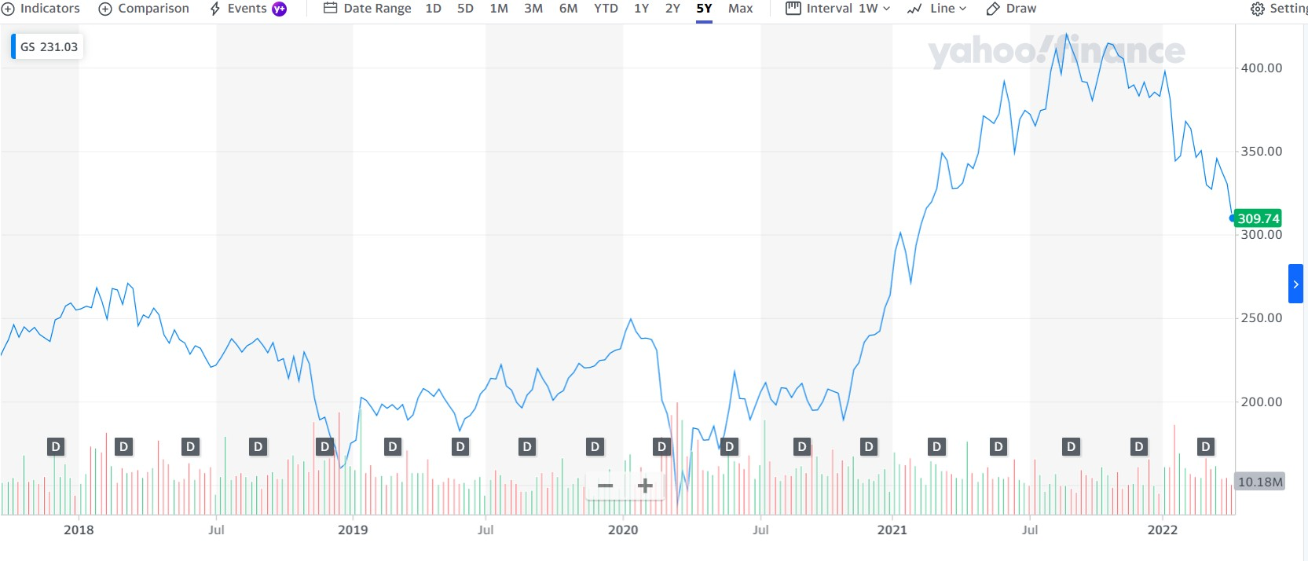

##### Enterprise Valuation utilizing industry EBITDA Multiple

EBITDA Multiple is a preferential financial ratio in evaluation of market willingness for Merger and acquisition, and the extent to which investors’ appraisal to an industry affects its valuation process to the target company. In comparison to other ratios’ instability, and oftentimes irrationality (as price-revenue ratio is more volatile and sometimes being negative), the multiple is being viewed as a fairer financial indicator to corporations’ valuation.

According to Nick et al, the EBITDA Multiple for the financial services industry are listed asfollows:

The chart presents companies with differing enterprise valuation ranges and its EBITDA multiple within the year of 2018. The industry average is at 9.7 for groups surpassing a 200 B$ threshold. In verification, we calculated several large financial group’s EBITDA Multiples, and the results are as follows:

The EBITDA Multiple for in past 4 years (data attracted on the 31/12 each year) - (in million $)

|  |  |  |  |
| --- | --- | --- | --- |
| **Time** | **EBITDA** | **Enterprise Value** | **EBITDA Multiple** |
| 2018 | 13,081 | 178,556 | 13,650 |
| 2019 | 13,944 | 209,578 | 15,030 |
| 2020 | 18,187 | 248,980 | 13,690 |
| 2021 | 23,599 | 289,796 | 12,280 |

This chart puts Morgan Stanley’s EBITDA Multiple in accordance with ’s projection. However, given that the stock prices’ may be significantly appreciated, and thus resulted in positive enterprise valuation which suggests that one could use its cash to pay off all interest-bearing debts and back all of one’s issued shares. The positive valuation of enterprises presents a unique situation where the combined market capitalization (the sum of its outstanding shares ‘value) is less than its cash reserves and other current assets. Take another investment management company as an example:

The EBITDA Multiple JPMorgan Chase & Co. for in past years (data attracted on the 31/12 each year)

|  |  |  |  |
| --- | --- | --- | --- |
| **Time** | **EBITDA** | **Enterprise Value** | **EBITDA Multiple** |
| 2018 | 46,7900 | 422,0458 | 9,0200 |
| 2019 | 51,4500 | 773,8080 | 15,0400 |
| 2020 | 42,7100 | 457,4241 | 10,7100 |
| 2021 | 65,6600 | 311,8850 | 4,7500 |

The unique position of JPMorgan Chase & Co. is the fruit of three characteristics of the company:

a. the non-debt financing structure, b. under-valuation by the stock market, and JPMorgan Chase & Co. the possession of increasingly current asset post-economic crisis.

The EBITDA Multiple Bank of America Corporation for in past years (data attracted on the 31/12 each year)

So,

\

|  |  |  |  |
| --- | --- | --- | --- |
| **Time** | **EBITDA** | **Enterprise Value** | **EBITDA Multiple** |
| 2018 | 36,650 | 235,660 | 6,430 |
| 2019 | 34,480 | 356,523 | 10,340 |
| 2020 | 20,840 | 93,780 | 4,500 |
| 2021 | 35,870 | 322,113 | 8,980 |

What about the company of interest, Goldman Sachs? – (in million $)

|  |  |  |  |
| --- | --- | --- | --- |
| **Time** | **EBITDA** | **Enterprise Value** | **EBITDA Multiple** |
| 2018 | 1868,043566 | 61701,479 | 33,03 |
| 2019 | 1939,271103 | 80867,605 | 41,7 |
| 2020 | 2563,990094 | 90072,972 | 35,13 |
| 2021 | 5775,493424 | 127349,63 | 22,05 |

# EBITDA MULTPLES AND GORDON GROWTH METHODS

#### Method 1 - DCF Using the Gordon Growth Model

**Method 2 - Multiples Using Enterprise-Value to EBITDA Ratio**

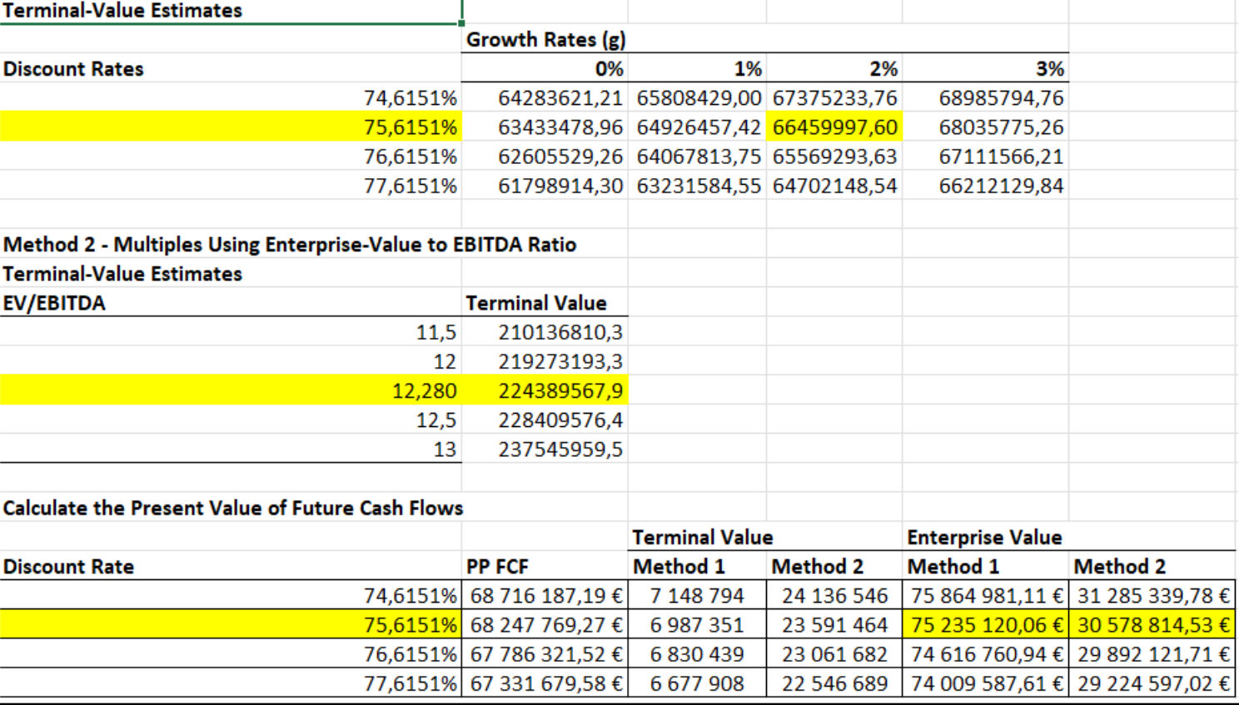

# USING P/E RATIO METHODS

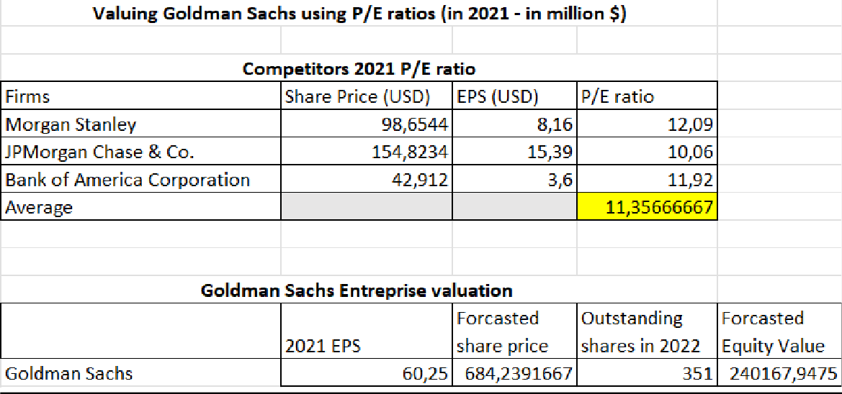

## Additional analysis: FINANCIAL RATIOS

|  |  |  |  |
| --- | --- | --- | --- |
| **LIQUIDITY RATIOS** | | | |
| **CURRENT RATIO** |  | 2021 |  |
| Current asset/current liabilities |  | 0.96 |  |
| Goldman Sachs has a current ratio of 0,96 which is not a good ratio. We can assume that Goldman Sachs doesn't have enough current asset to pay his short-term debt. Moreover, this ratio has increased over the last four years, Unfortunately, we have only found the average industry (Security and Commodity Brokers, Dealers, Exchanges, And Services industry) for 2021 but we can say that Goldman Sachs 's current ratio of 2020(0.76) was higher than the average industry in 2020 (0.18). | | | |
| **CASH RATIO** | | | |
| Cash/total current liabilities |  | 0.962 |  |
| The company has a cash ratio of 0.96 in 2021, so the company can't pay his short-term liability with its cash. But those values are normal in the financial services industry average | | | |

|  |  |  |  |
| --- | --- | --- | --- |
| **SOLVENCY RATIO** | | | |
| **DEBT RATIO** |  | 2021 |  |
| Total liabilities/assets |  | 92% |  |
| Goldman Sachs has a debt ratio of 92% which means that 92% of the assets are financed by debt. Between 2019 and 2020, this ratio hasn't changed a lot and we can assume that the company has more assets than debt. If we must compare to the industry the debt ratio was 34% in 2019, so compare to its competitors Goldman Sachs use a lot the debt to finance its assets. | | | |
| **DEBT TO EQUITY RATIO** | | | |
| Total liabilities/total equity |  | 11.12 |  |
| The debt-to-equity ratio is very high. It is greater than 1 so Goldman Sachs finances more assets with debt than equity. The amount of total liability and equity have increased over the last three years however the amount of liability is always higher than the amount of equity. | | | |

|  |  |  |  |
| --- | --- | --- | --- |
| **PROFITABILITY RATIO** | | | |
| **Return on asset** |  | 0.9% |  |
| Return on equity |  | 10.1% |  |

|  |
| --- |
| **INVESTMENT RATIO** |
| Fund Asset Allocation for Goldman Sachs. The fund consists of **47.6%** investments in stocks, with the rest of investments allocated between different money market instruments. |

1. **References**

**REFERENCES**

1. Balance sheet published by Goldman Sachs on Yahoo Finance [GS 309.51 -6.75](https://finance.yahoo.com/quote/GS/key-statistics?p=GS)

[-2.13: The Goldman Sachs Group, Inc. - Yahoo Finance](https://finance.yahoo.com/quote/GS/key-statistics?p=GS) accessed on 06/04/2022

1. Historical Data of Goldman Sachs EV, Provided by YCharts, <https://ycharts.com/companies/MS/enterprise_value>, accessed on 06/04/2022
2. How much are companies worth in the Financial Services sector? Nick B. et al (Jan.2021), <https://www.corbettkeeling.com/sectors/financial-services>accessed on06/04/2022
3. Goldman Sachs Statements 2005-2021 | BLK, [https://www.macrotrends.net/stocks/charts/BLK/blackrock/financial-statements?q=](https://www.macrotrends.net/stocks/charts/BLK/blackrock/financial-statements?q=enterprise%2Bvaluation) [enterprise valuation](https://www.macrotrends.net/stocks/charts/BLK/blackrock/financial-statements?q=enterprise%2Bvaluation) accessed on 06/04/2022
4. Database of Goldman Sachs Enterprise Valuation

[Goldman Sachs (GS) - Market capitalization (companiesmarketcap.com)](https://companiesmarketcap.com/goldman-sachs/marketcap/) on 06/04/2022

1. Database of SCHW Enterprise Valuation, <https://ycharts.com/companies/SCHW/enterprise_value>, accessed on 06/04/2022
2. GURU FOCOUS.COM (November 7, 2019). Negative Enterprise Value: Does ItReally Mean Money for Nothing?

[https://finance.yahoo.com/news/negative-enterprise-value-does-really-215939487. html](https://finance.yahoo.com/news/negative-enterprise-value-does-really-215939487.html)

1. Goldman Sachs Financial Statements 2005-2022 | GS, [Goldman Sachs Current Ratio 2010-](https://www.macrotrends.net/stocks/charts/GS/goldman-sachs/current-ratio) [2021 | GS | Macrotrends](https://www.macrotrends.net/stocks/charts/GS/goldman-sachs/current-ratio)
2. Goldman Sachs’s corporate bond

finra-markets.morningstar.com

1. Listed of the different ratios of the security brokers, dealers, and flotation companies: https://[www.readyratios.com/sec/industry/6211/](http://www.readyratios.com/sec/industry/6211/)